**Hello World: Write your first python Program**

In the previous tutorial we had created project with the name “helloWorld”

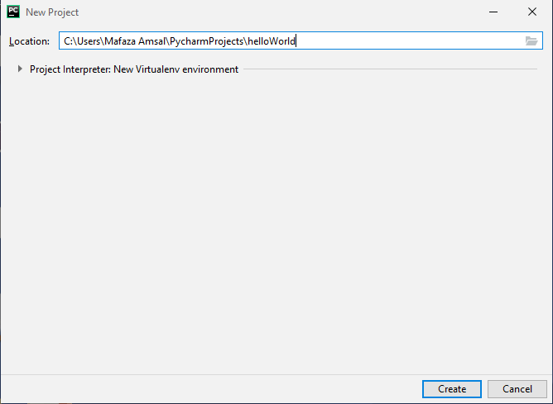

**Step 1:** Click on the file on the top left of the PyCharm editor and select new as shown in the editor below.

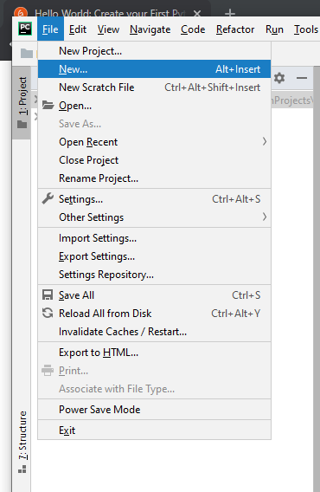

**Step 2:** Then select “Python file” as shown below.

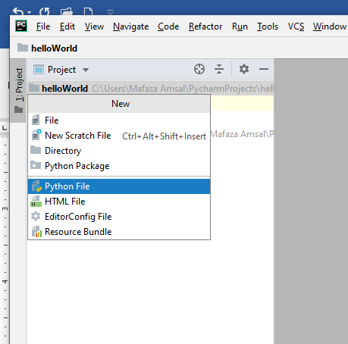

**Step 3:** write the name of file “helloWorld” and press enter.

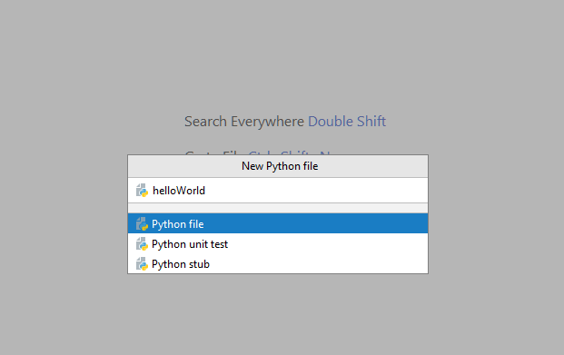

**Step 4:** Now you have the space to write your first program. Write “print(“hello world”)”

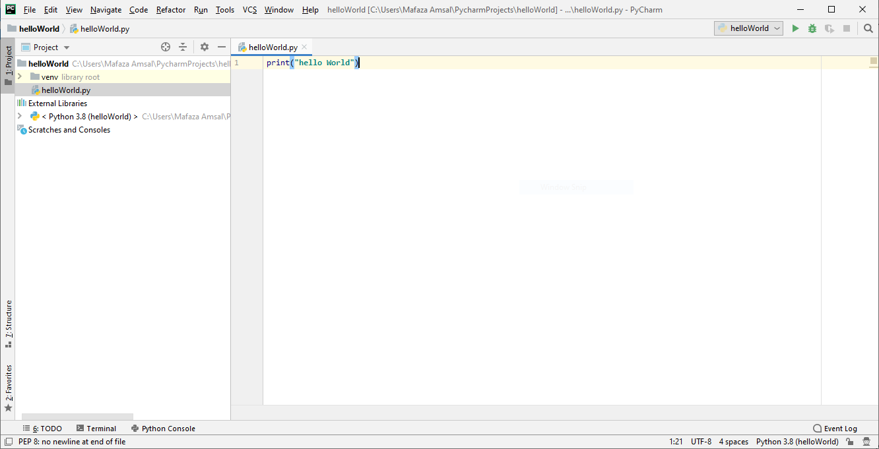

**Step 5:** Right click on the white space and menu will be shown.

Then select “Run ‘helloWorld’”

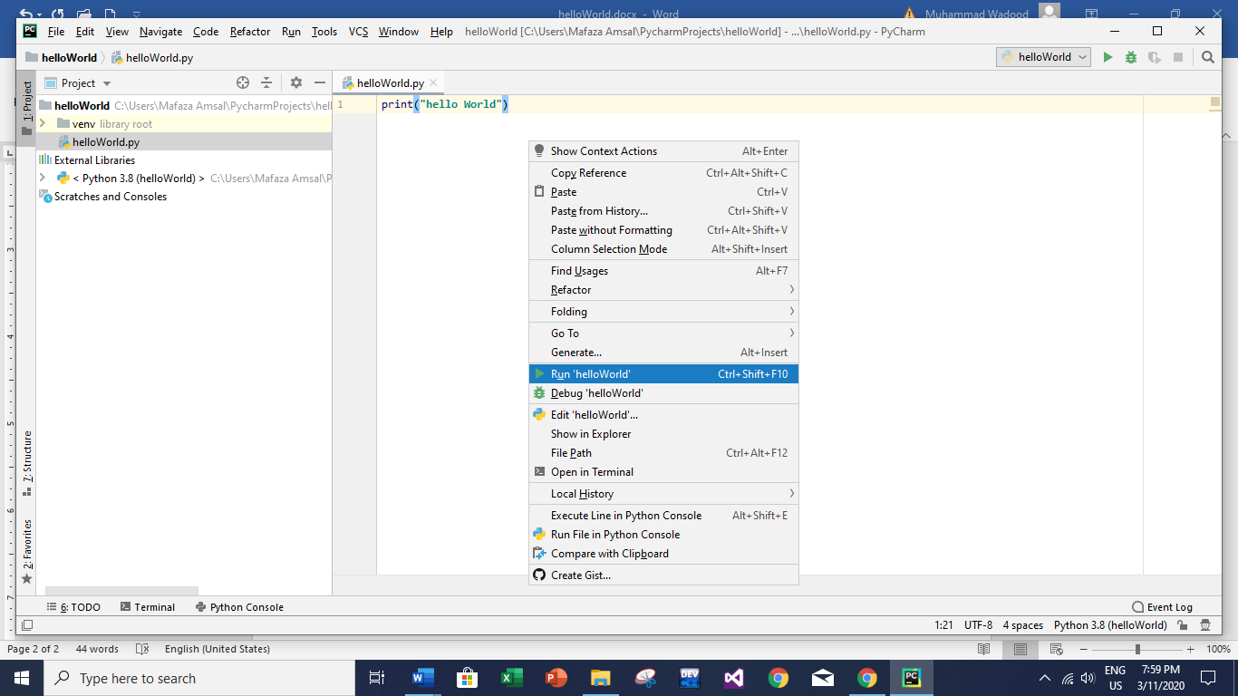

**Step 6:** Below a terminal will open and the output of the program will be shown.

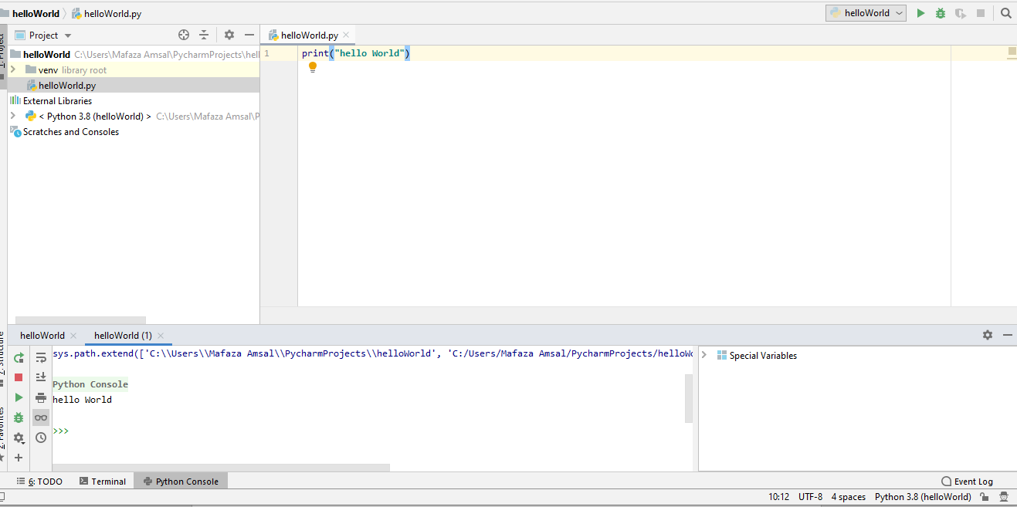

**Congratulations you have successfully written you first program.**

**Rectangle Example**

Now let us see how we can simply draw a rectangle using **print()** statement. Python execute the code line by line. We are going to use ‘*’ to print the rectangle. Simply write the program as shown below.

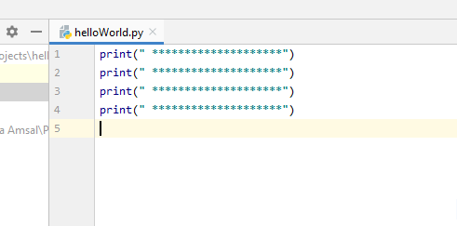

Then repeat **step 5** to run the program.

You have successfully drawn the rectangle.

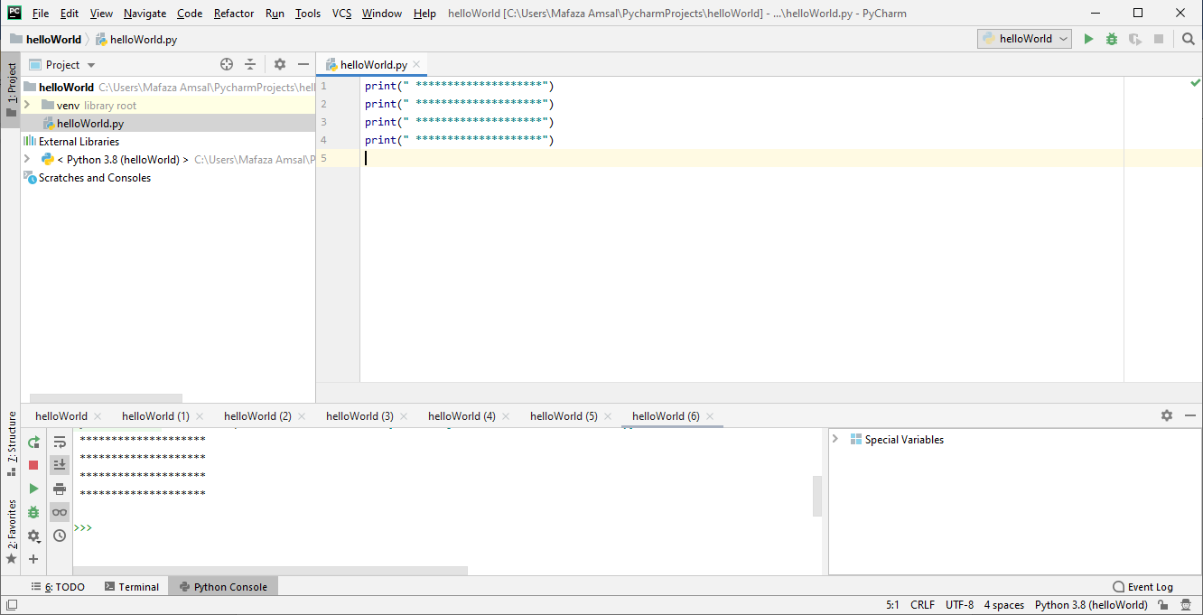

In the upcoming tutorials we will see how we can reduce the repetitions of writing the same lines of code.

**How to print blank lines**

Python allow three ways to print blank lines.

1. print()
2. print(“ ”)
3. print(“write backward slash n at end of text\n”)

Let us try all the three ways to print blank lines.

Line 1 and 2 have no blank space between them.

Line 3 and 5 prints a blank space.

Line 6 uses “\n” at the end to print the blank space.

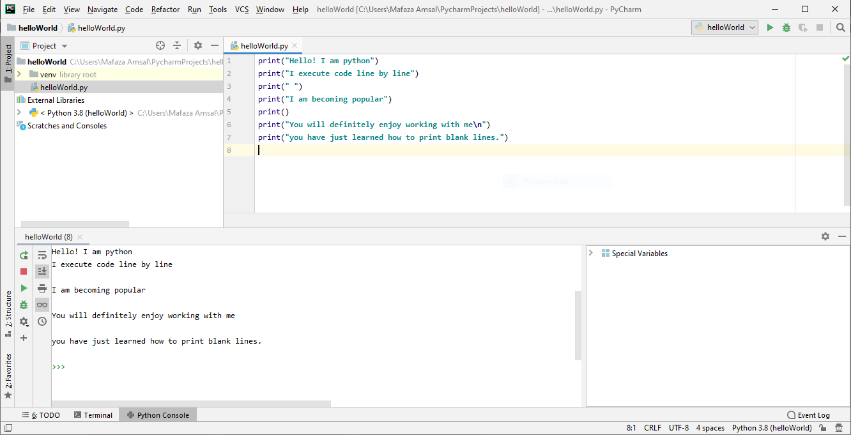

**Use of end in print()**

As print is a function, we can pass an “end” optional parameter. If you don’t understand parameters don’t worry, you will understand in the upcoming function tutorials. “end” is used to tell the print statement how we want to end the print line. In the previous examples we used default end parameter which automatically end the line.

Let’s understand with example.

Line 1 and 2 are simple print statements as we use print statement previously.

Line 3 prints a blank line.

Line 4 uses end=” “means “end this print line with a blank whitespace not with blank line”.

Line 7 uses end=”---" means “end this print line with ---”.

See the difference in the output.

